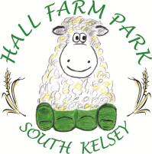

Eat in menu
Homemade seasonal soup - served with white or granary bread £3.85

Sandwiches – ham, cheese & pickle or tuna mayo made on white or granary £3.95 bread served with a salad garnish or crisps

Paninis – cheese & onion, tuna & cheese, bacon & brie, brie & cranberry £4.85 or ham & cheese served with a salad garnish or crisps
Toasties – cheese with ham, onion, tomato or chutney served on £4.00 white or granary bread with a salad garnish or crisps
Jacket Potato - filled with tuna mayo, cheese, coleslaw or baked beans £4.95 served with a salad garnish (Extra toppings 80p)
Beef burger – served with a salad garnish or crisps (add cheese for 50p) £4.00
Vegetarian mozzarella burger – served with a salad garnish or crisps £4.00
Bacon or sausage butty £3.50 (add £1.20 for both)
Vegetarian/vegan sausage butty £3.50
Beans on toast – served on white or granary toast £3.50
Toast – white or granary 85p
Sausage roll £1.20
Children’s
Lunch box – ham or cheese roll, crisps, raisins, chocolate bar and juice drink £4.20
Beans on toast - £2.95
Sausage or bacon butty - £2.95
Half jacket potato – served with either beans or cheese £2.95
Please let us know of any allergies/ intolerances when placing your order, thank you.

