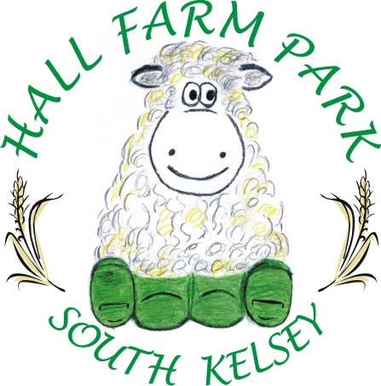
Schools Pack
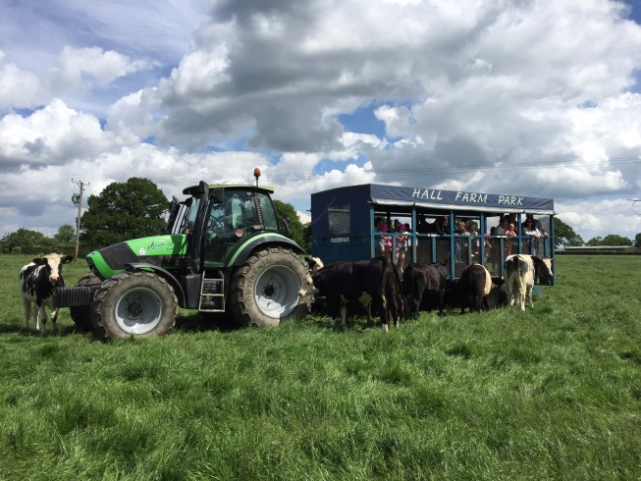
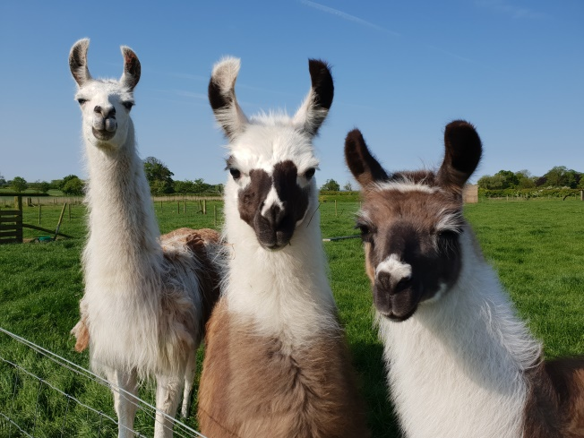

Hall Farm Park, Caistor Road, South Kelsey, Lincolnshire, LN7 6PR
Telephone 01652 678822
Website: www.hallfarmpark.co.uk
Email: hallfarmparkoffice@keme.co.uk

Partners: A C Knapton, Mrs T A Knapton, K C Knapton, Mrs V F Knapton

Opening times:
February half term – October half term: open every day 10am - 4pm except Wednesday when we are closed.
1st November - February half term: open Thursday, Friday and Weekends 10am -4pm

School charges:
£4.95 per child / adult
1 adult free with every 10 children
Included in this is a complimentary free pre-visit for members of staff overseeing the trip.

Clothing:
We suggest that whatever the time of year you visit us, children wear sensible, sturdy shoes or trainers. Wellies are advisable if the weather is wet as the nature walk can become muddy.
If the children want to bring wellies to change into, we advise that they are labelled; they can be left in the education room until needed.

Risk Assessment:

A risk assessment will be forwarded upon request.

Facilities:

• School room in which packed lunches can be eaten and where bags etc can be safely left.
• Hand-washing facilities in all buildings
• Separate accessible toilet and hand-washing facilities
• Pathways linking the main areas for ease of access
• A shop containing a range of goods which can be purchased – several items costing under £2
• Large car parking area

Organisation:

Hall Farm Park is part of the National Farm Attractions Network and was a shortlisted business for Best Small Farm Attraction in 2020 and Rural Business Awards Midlands winner in the best rural diversification project and best rural tourism business category 2019/20.

It is owned and run by Mr Andrew Knapton, his wife Mrs Tracy Knapton and their son and daughter. Tracy is a qualified primary school teacher and Andrew has undertaken extensive training with the Countryside Educational Visits Accreditation Scheme (CEVAS) to qualify him to organise and cater for school visits. All of the farm park staff have had training appropriate to their duties and are happy to assist you in any way then can to make your visit a happy one.

School bookings can be made over the telephone. A booking confirmation will be sent along with a timetable showing your activity times.

Activities:

Animal Barn and Paddocks
We have a wide range of animals; traditional farm animals, rare breeds and domestic pets. On the gates you will find details about all of them, including their names, ages, origins and much more. Find out why they are found on a farm, take their photographs to use back in the classroom for art, science, literacy and numeracy activities, sit and sketch them (they like to pose).

Woodland Walk
The woodland walk takes in a range of different habitats – grassland, woodland and cultivated fields with lots of informative signboards along the way. As you walk, look and listen for the different species of wildlife. Note the different types of plants you see, decide which occur naturally and which have been introduced. There are many surprise nature boxes along the route. As you venture into the wood look out for bug hotels and other very special little inhabitants called “ Pingles.” A nature quiz sheet will be sent with your confirmation of booking form, please feel free to adapt/photocopy this as needed.

Tractor and Trailer Ride
We offer a tractor and trailer ride to see the farms cattle as part of the school visit but would appreciate it if you could confirm on booking if you wish to partake in this activity. Our tractor and trailer meets all safety regulations but children must be accompanied by at least two adults on the ride, be kept seated at all times and keep all parts of their body inside the trailer for safety reasons. It may be necessary to split your party into groups as our trailer can only take a maximum of 30 people.

Goat walking

Have you ever walked a goat?! All of our goats love attention and just can’t wait to say hello. You can stroke them and help us take them for their daily walk in our dedicated goat walking area. The goats can be very strong so please allow 1 adult with every 4 children for this activity.

Lamb feeding

Every year between mid-March and May we are very busy on the farm looking after all the baby lambs and pregnant ewes. Baby Lambs take a lot of looking after and just like human babies need regular feeds of milk. Not all lambs are able to be looked after by their own mums and so need bottle feeding. Children can enjoy this activity on visits between March and May (please contact us for exact dates).

Heritage Shed
The heritage shed is an original building which has stood in the field for hundreds of years as a watering / feeding place for the farm horses and farm workers in years gone by. The original troughs can be seen. Note the feeding height of them to indicate the size of the horses. This shed gives the field its name and by which it has been known as long as anyone can remember – Shed Field. All our fields retain their traditional names -Cunney Greens, Gravel Pit, Pingle Wood, to name but a few.

Housed in the shed are farming implements and household items from previous generations. All have explanatory labels. Take time to look, wonder and sketch. Please note that a maximum of 12 children can be fitted in this shed at any one time.

Play Areas (Indoor, Outdoor and Go-karts)

Whatever the weather, there is opportunity for exercise and play. The outdoor play area comprises an agility style assault course, swings, trampolines and a play fort.

The indoor play barn houses a slide complete with inflatable rings to slide down in, soft play, bouncy castle, a huge sandpit with diggers and pedal tractors etc. There is plenty of seating for staff (who don’t want to join in)!

The pedal go-kart track (complete with pit lane), offers lots of make-believe races for budding Lewis Hamilton’s.

