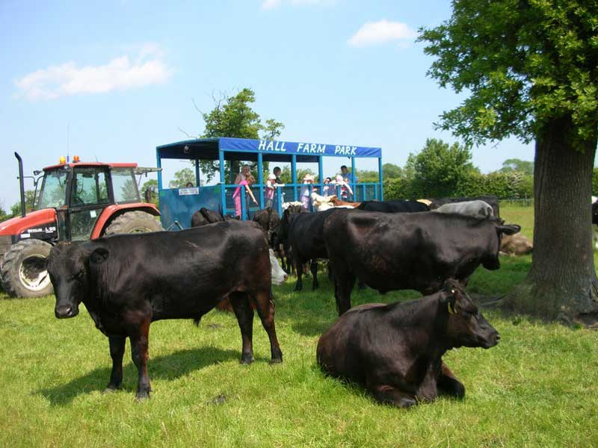

**Birthday Parties at Hall Farm Park**

Hold your birthday party at Hall Farm Park and be

assured of a fun time for all, whatever the weather.

|  |  |
| --- | --- |
| **Party option 1 - £10.95 per child** | **Party option 2 - £11.95 per child** |
| ▪Admission to the park and full use of all of its facilities  ▪Party invitations  ▪Birthday meal – individual party meal boxes and unlimited squash.  ▪Tractor and trailer ride  ▪Party gift for each child  ▪Parties are scheduled to last for 2 hours; however you are welcome to stay longer, at no extra cost, if you wish  ▪Minimum number of children at the party is 8 and the maximum is 25  ▪One adult is admitted free per child (does not include food). Birthday child’s parents and grandparents are admitted free of charge. Extra adults £4 each  ▪Birthday cake provided if ordered in advance (additional charge)  ▪£30 deposit (non-refundable) is required to secure the booking  ▪Our staff will be on hand to assist you, but kindly note that your child and guests are your responsibly at all times | ▪As for option 1 (excluding party gift)  ▪Party bag for each child |

`



Hall Farm Park, South Kelsey, LN7 6PR Telephone: 01652 678822

www.hallfarmpark.co.uk Email:hallfarmparkoffice@keme.co.uk