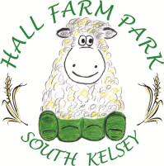
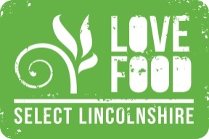

Eat in menu
Homemade seasonal soup - served with white or granary bread £3.95
Sandwiches – Ham, cheese & pickle or tuna mayo made on white or granary £3.95 bread served with a salad garnish or crisps.

Paninis – cheese and onion, tuna and cheese, bacon and brie, brie and cranberry, £5.00 ham and cheese or cheese and chutney served with a salad garnish or crisps

Jacket Potato - filled with tuna mayo, cheese, coleslaw or baked beans £ 5.20 served with a salad garnish (Extra toppings 80p)

Bacon or sausage butty – £3.70 (add £1.20 for both)
Vegetarian/vegan sausage butty - £3.50
Beans on toast – served on white or granary toast £3.90
Toast – white or granary 85p
Sausage roll – served hot or cold £1.30

Children’s
Lunch box – Ham or cheese roll, crisps, raisins, chocolate bar and juice drink £4.30
Beans on toast - £3.20
Sausage or bacon butty - £3.00
Half jacket potato – served with either beans or cheese £3.00

